Navigation
Exercise #01
Flutter Developer Bootcamp

Purpose
This Exercise defines a Flutter screen for user signup. It includes input fields for name, number, and password, along with buttons for signup and social media login.

Problem
The Flutter Exercise defines two classes: home and Notification Screen. The home class represents a home screen with a notification button that navigates to the Notification Screen. The Notification Screen class displays a list of notifications.

How to Solve
1. Checkout the workshop from Git Repo:
git clone -b <user-branch> <repo-URL>
2. Open the root folder inside VS Code
3. To build the app click the run option in the main method { }
4. AppBar:
- Define an app bar with an action button for navigation.
5. Images:
- Display a list of images in a column below the app bar.
6 NotificationScreen Class:
- Define a stateless widget called Notification Screen.
- Constructor has no properties.
- Override build method to define UI for notification screen.
7. Notification Screen UI:
- Return a Scaffold widget with app bar and body containing a ListView of notification items represented by ListTile widgets.

You Will Achieve

By implementing the provided Flutter Exercise , you'll achieve a basic mobile application with two screens:

Achievement:
- Home Screen:
  - Displays a title "Home" in the app bar.
  - Shows a list of car images.
  - Includes a button to navigate to the notification screen.
- Notification Screen:
  - Presents a list of notifications.
  - Each notification can be deleted individually.
This achievement represents a fundamental structure for a Flutter application with navigation and basic UI components.

Screenshots

Expected Output
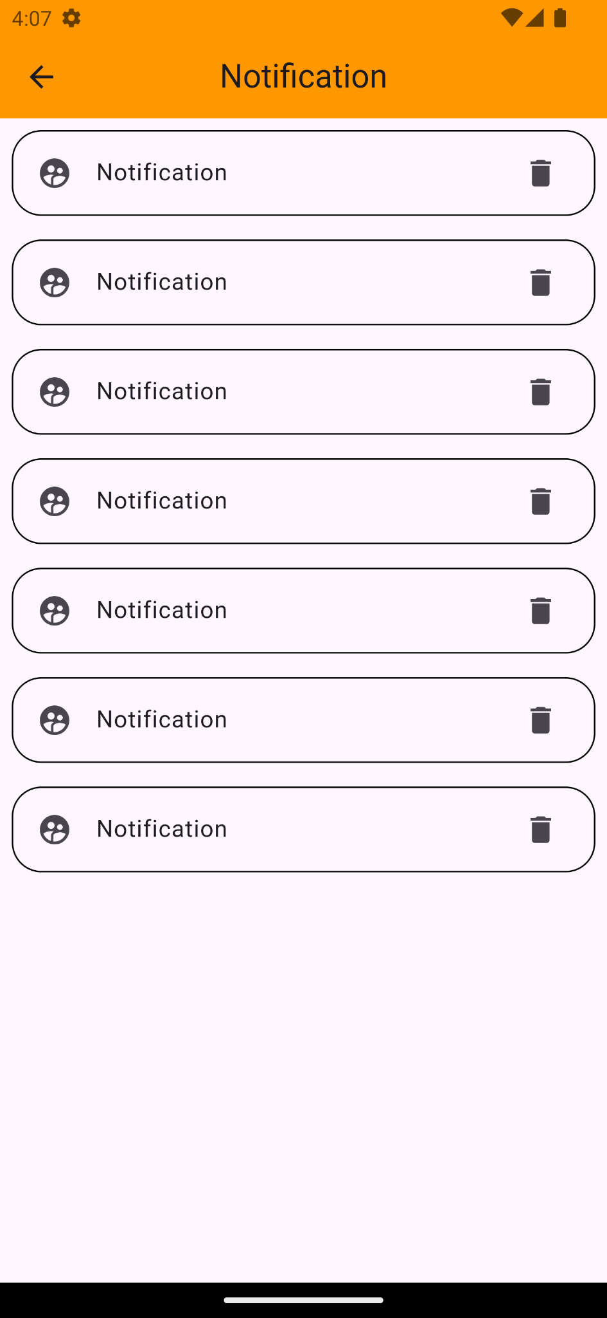

How to submit your Exercise
Push your project back to the same git branch using command:
<command name>

Happy Coding!

